Catholic Foundation of Southern Minnesota

Seeds of Faith • Faith Formation Endowment

Our Catholic faith is universal – one teaching, one Church and one Body of Christ. From cradle to grave each of us learns of and experiences this faith most immediately and intimately in our local parish. The bishop, as teacher of the faith, has the responsibility to assure that lifelong formation is a priority in the parishes and that the faithful are afforded opportunities to grow in the life of Christ through prayer and by experiences, reflections and studies. Critical to these efforts are faith-filled and competent catechetical and pastoral ministers.

**What is the “Faith Formation Endowment”?**

Our diocesan Seeds of Faith appeal made possible the establishment and funding of a Faith Formation Endowment. The annual earnings from this $1 million endowment provide support for projects and initiatives which seek to evangelize and catechize God’s People within our Diocese, and to support the education and formation of lay ministers serving across southern Minnesota.

**Who does the Endowment support?**

The Faith Formation Endowment provides funds for the evangelization and catechesis of the Catholic faith community within the Diocese of Winona. It also provides funds for the training, mentoring, and development of: directors of faith formation; catechists; adult faith formation leaders; Catholic school educators; youth ministers; pastoral ministers; liturgical ministers; parish pastoral council members; Hispanic and multi-cultural ministers; leaders of small faith communities, etc.

**How are Endowment funds used?**

Faith Formation Endowment funds support:

* Diocesan-based initiatives and partnerships designed to enhance and strengthen broad-based faith formation efforts (e.g., diocesan ministry days, evangelization events, lay formation programs and initiatives, etc.).
* Deanery, multi-parish, parish, and other ministry based efforts in support of evangeli-zation, faith formation, and leadership development.
* Parish staffs and individual ministers in graduate theological education and continuing formation in ministry.

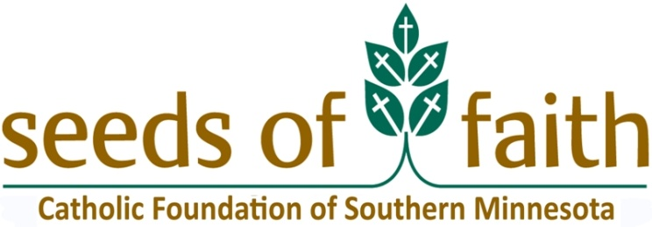



*To learn more about the Faith Formation Endowment and/or to submit an application for funding, please contact:*

***Monica Herman – Catholic Foundation of Southern Minnesota – P.O. Box 30098– Winona, MN 55987***

***Phone: (507) 858-1276/ Fax: (507) 454-8106 / E-mail: mherman@catholicfsmn.org***